Leriloe Gutiérrez Soto – Getting and Cleaning Data

*Manipulating Data with dplyr*

*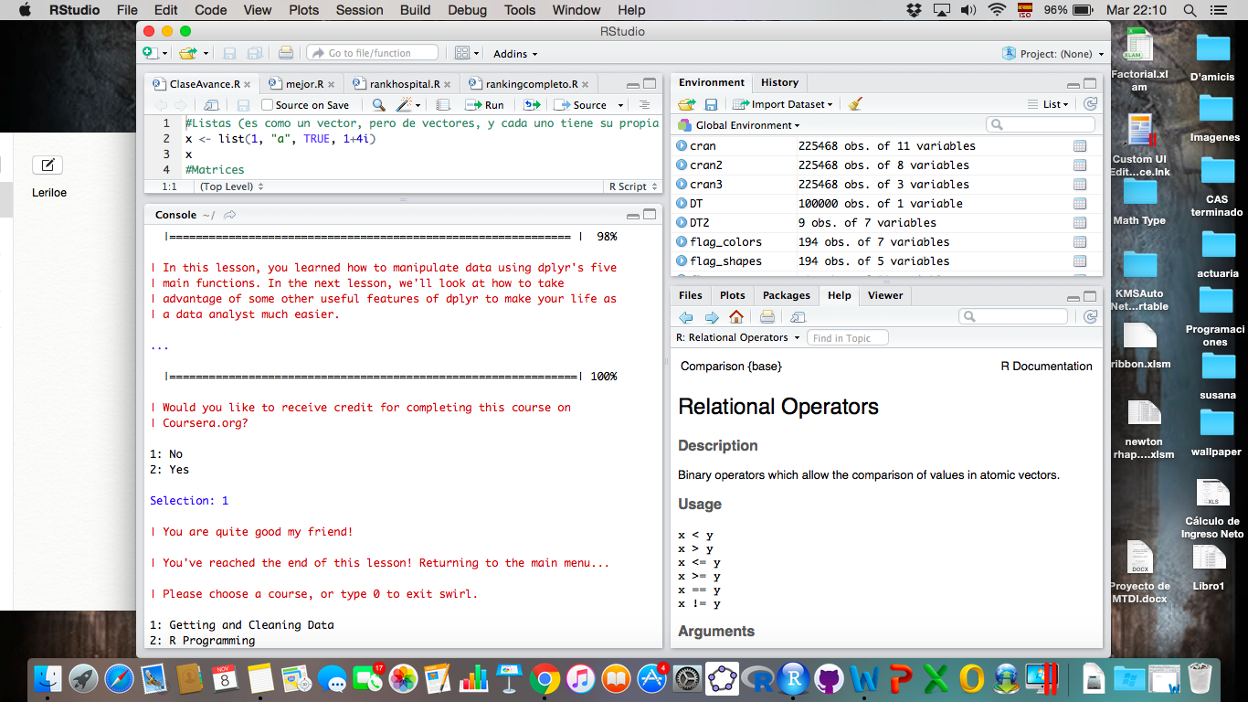*

*Grouping and Chaining with dplyr*

*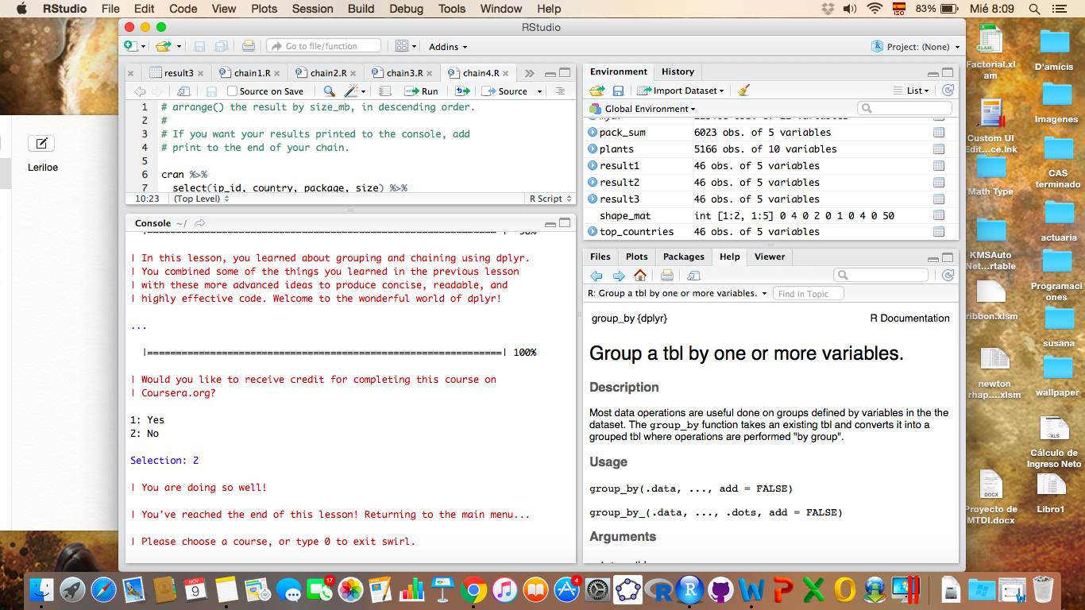*

*Tidying Data with tidyr*

*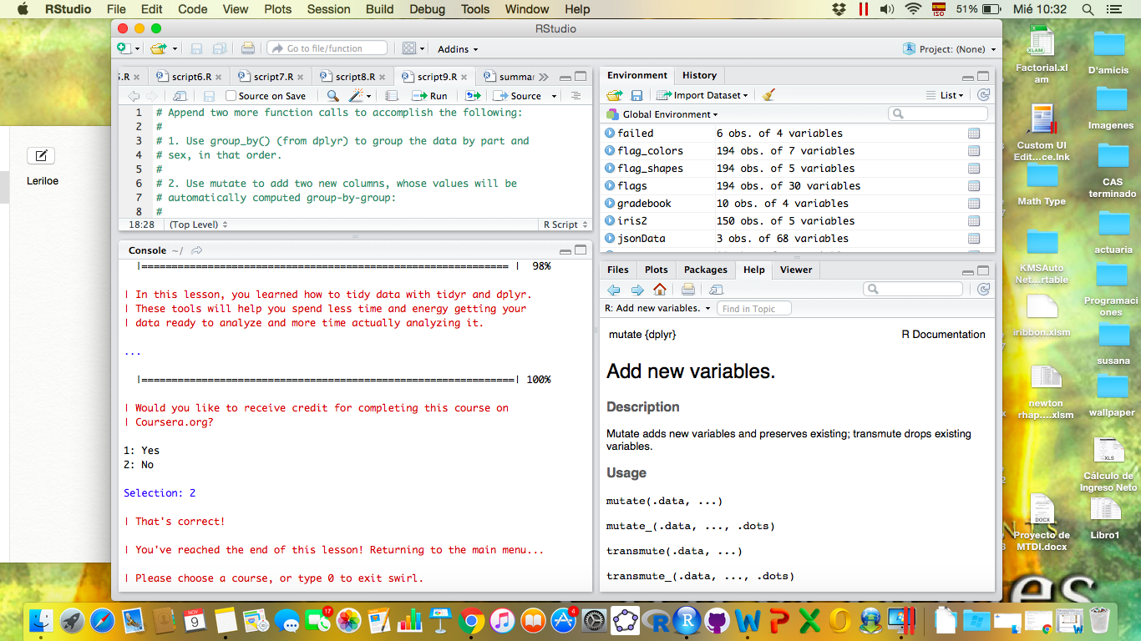*

*Data and Times with lubridate*

*